Development Of

Automotive Cruise Control System

Using 20Sim Software

1Sandeep Bari*,* 1Narendra Rajpurohit, 1Mayur Hodage-Patil, *BE-EnTC, VIIT Pune*

2S. H. Bhagawat, Professor, EnTC, VIIT Pune

Vinay Sharma, Co- Founder, ni logic Pvt. Ltd., Pune

***Abstract*-** This paper deals with the design, modulating and estimation of the controllers performing actions on the longitudinal control of a car to accomplish speed control. Recent advances in automotive technology such as sensing and onboard computation have resulted in the development of Automotive Cruise control (ACC) algorithms that improve both comfort and safety. With a view towards developing advanced controllers for ACC, this paper presents an experimental platform for validation and demonstration. Going beyond traditional PID based controllers for ACC that lack proof of safety, using 20Sim Software we construct a control framework that gives formal guarantees of correctness. The system performance during Speed Control and Stop-and-Go situation on all road grades and for all speed ranges has been satisfactory and the proposed controller yields favorable overshoot, rise time and settling time as compared to similar works. In this paper, we present a case study on Automotive Cruise control as modelled on the electric vehicle.

*Keywords*: Automotive Cruise Control, longitudinal control, PID, controlled framework, 20Sim Software.

1. **INTRODUCTION**

Cruise control is needed in today’s life because now a days the long road trips become hectic for a driver. In that if there’s only person who is capable of driving then it is very frustrating for him to drive continuously on the roads. In order to overcome this problem cruise control plays an important role. It can remove the frustrating driving hours of the drivers. The ACC is a system that automatically controls the speed of a car. The purpose of ACC system is to accurately maintain a speed set by the driver without any outside intervention by controlling the input to the DC motor through pedal linkage. The driver interface for the ACC system is very similar to a conventional car. The driver operates the system via a set of switches on the steering wheel. The cruise control system is capable of being turned off both explicitly and

implicitly when the driver depresses the brake or through the OFF switch. Going beyond traditional

PID based controllers for ACC that lack proof of safety, using 20Sim Software we construct a control framework that gives formal guarantees of correctness. 20-sim supports four methods for modelling dynamic systems: iconic diagrams, block diagrams, bond graphs and equations and allows all of these methods to be used in one model. For modelling physical systems, the package provides libraries for electrical systems, mechanical systems, hydraulics systems and thermal systems. A feature of the software is the option to create models with differential equations and package them as block diagram elements or physical components. 20-sim models can be simulated using state of the art numerical integration methods. After checking and processing, models are directly converted into machine code, resulting in high speed simulations. This shows how safety and ease of driving can be achieved using ACC. The driver is relieved from the task of careful acceleration, deceleration and braking on the roads. Since the breaking and acceleration are done in a systematic way, the fuel efficiency of the vehicle is increased. There are a series of text messages that can be displayed on the display to inform the driver of the state of the ACC system [5].

1. **LITERATURE SURVEY**

[2] As shown in Figure 2.1, we can observe the development of self-driving cars research  
throughout the last decades, demonstrating at the same time a continuous increase of the interest  
on the topic as well as important milestones that can also influence the topic development and  
research. Furthermore, from 2013 to 2014 a rapid increase of 60.8% can be observed, which can be related to the actual interest on the topic.

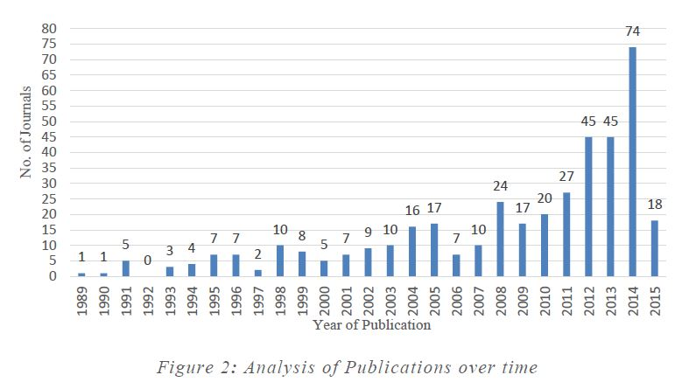

**Figure 2.1**

Furthermore, a journal count analysis was conducted in order to understand which journals were more dedicated to the topic depending on the number of articles released, all journals with more  
than 5 publications are shown in Figure 2.2. “IEEE Transactions on Intelligent transportation  
systems “and “Robotics and Autonomous Systems” resulted to be the ones more focused on the  
topic with 17 publications each. This analysis shows the first hint on the natural focus of the  
literature in the technology development phase, as most of the listed journals are mainly technical  
and not specialized in the field of business and management.

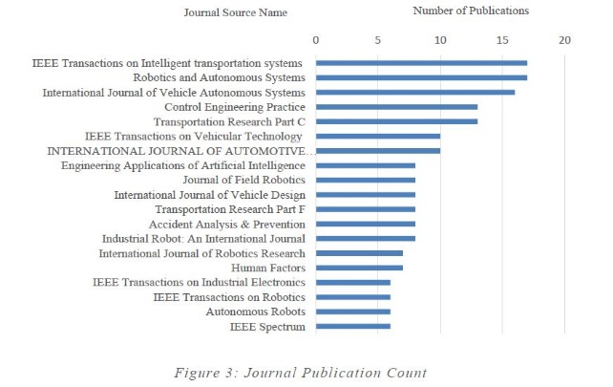

**Figure 2.2**

[1] The motor vehicle environment has gone virtually untouched by the technology explosion of  
the past decade - especially the computer revolution. Except for the use of microprocessors as an adjunct to pollution control and engine management; technology has, for the most part, not  
affected the Roadway environment - automated traffic lights notwithstanding. Each year there  
are thousands of highway deaths and tens of thousands of serious injuries due to “Run-Off-road" accidents. Everything from simple drive in attentiveness, to fatigue, to driving-while impaired, is responsible. The cost to the nation is the thousands of lives lost, and tens of millions of rupees. This is a much more common cause of single vehicle fatalities than is generally thought.

1. **OPERATIONAL OVERVIEW**

The overall procedure of Automotive Cruise Control algorithm is depicted in figure and different steps and stages in the proposed methodology are shown below.

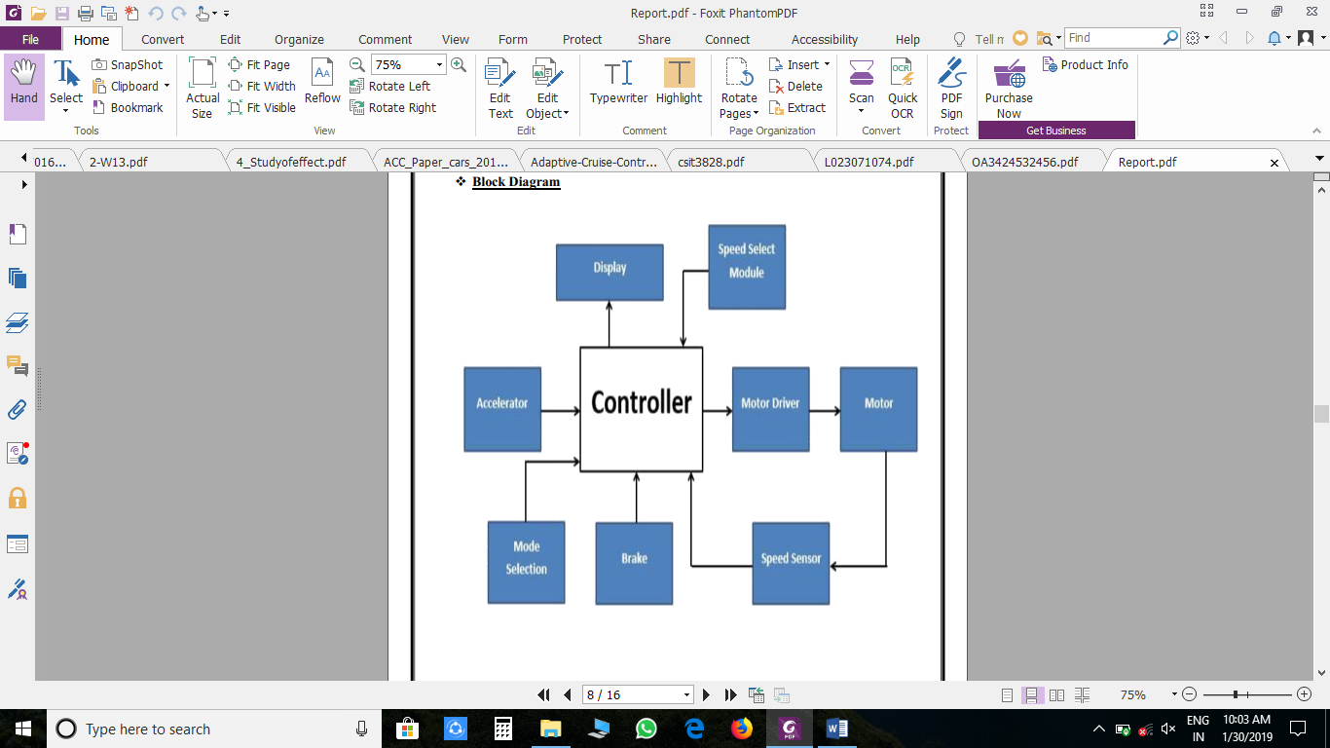

**Figure 3.1 Block Diagram**

Acceleration will be done using potentiometer. The ACC takes its speed signal from a rotating motor through encoder or from internal speed pulses produced electronically by the vehicle which gives the RPM of the vehicle and it will be displayed on the LCD. In order to decrease the wirings, I2C module will be used. The driver operates the system via a set of switches on the steering wheel. The driver engages the ACC system by first pressing the ON switch which places the system into the 'Cruise Control Mode' state. The driver then presses the ‘Set+’ switch to control the vehicle to the driver's set speed. With the help ‘Res-’ Button the speed of the vehicle will be decreased with a constant factor, shown in figure 3.2.

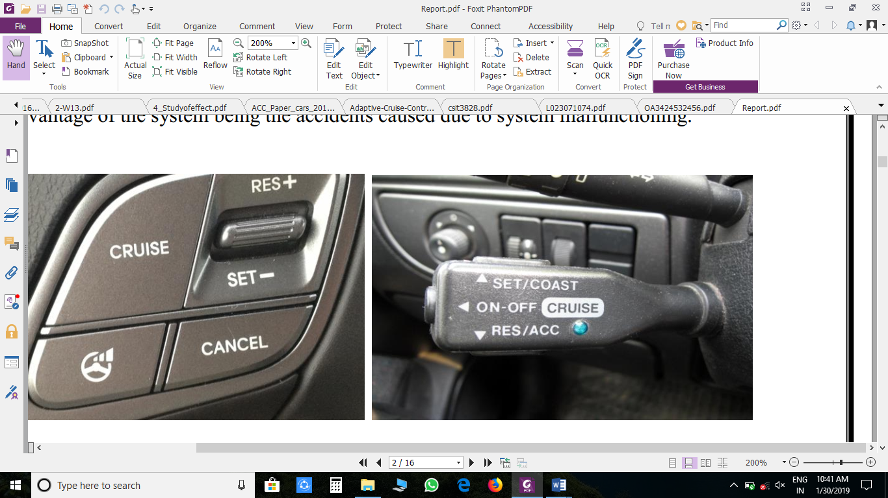

**Figure 3.2**

The cruise control system is capable of being turned off both explicitly and implicitly when the driver depresses the brake or through the OFF switch. While being in the ‘Cruise Control Mode’ the ‘Acceleration’ will not be in function.

1. **SYSTEM MODELLING**

[3][4] Normally, the inertia of the wheels of the car is neglected. Assuming the friction of the car is obtained by the friction caused by the motion of the car. A physical model of the cruise control system is illustrated as shown in Fig. 4.1. The m indicated as the mass of a car.

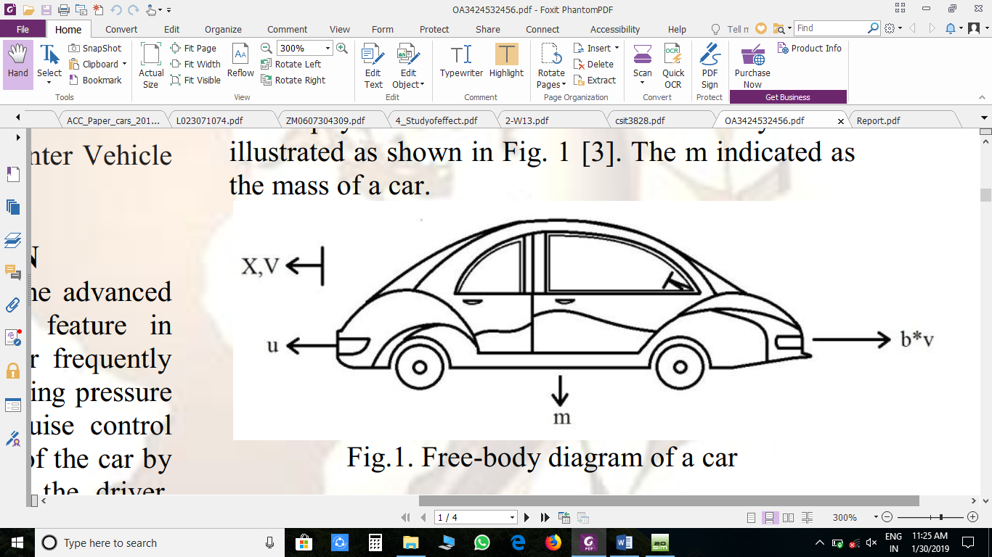  
**Figure 4.1**

Free-body diagram of a car from the Newton’s second law of motion, a differential equation of the cruise control model can be obtained, as in Eqn. (1)

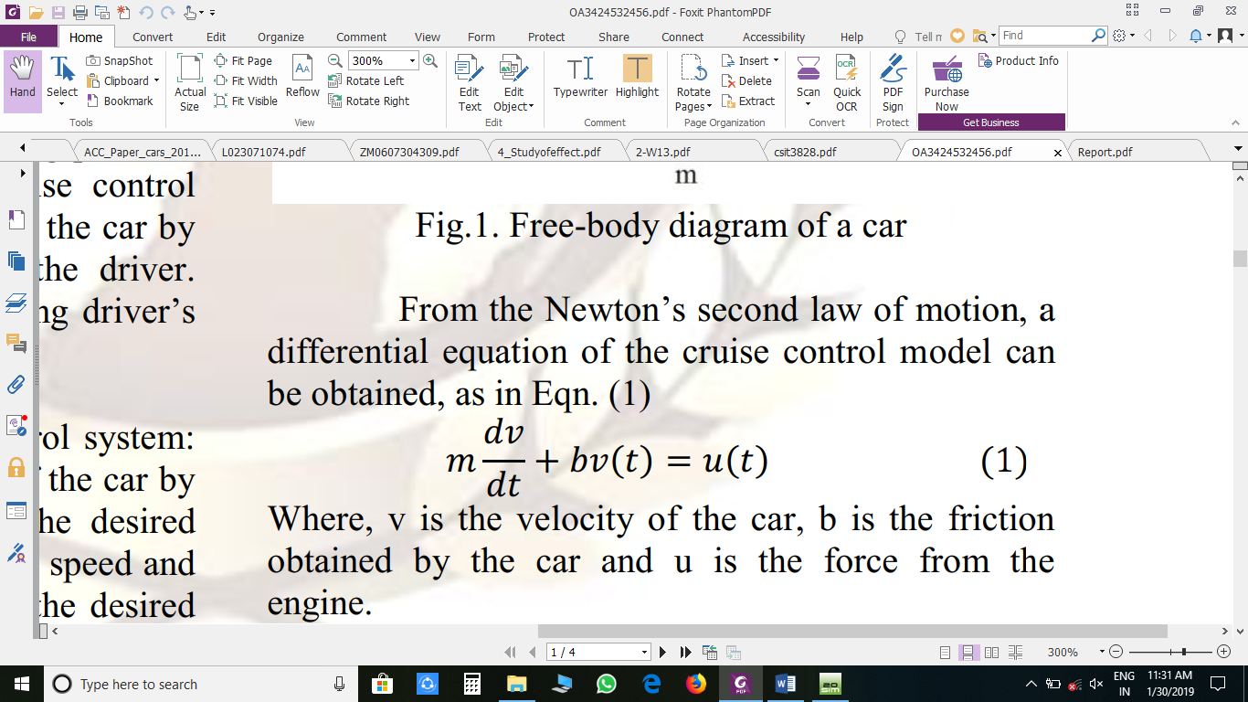

Where, v is the velocity of the car, b is the friction obtained by the car and u is the force from the engine.  
Now taking Laplace transform of eqn.1

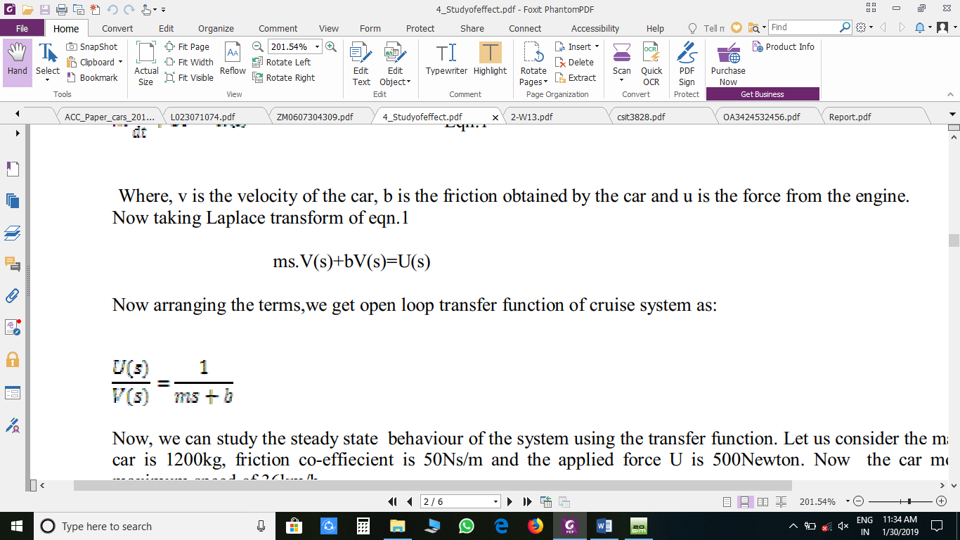

Now arranging the terms, we get open loop transfer function of cruise system



This equation helps in studying the steady state behavior of the system using the transfer function.

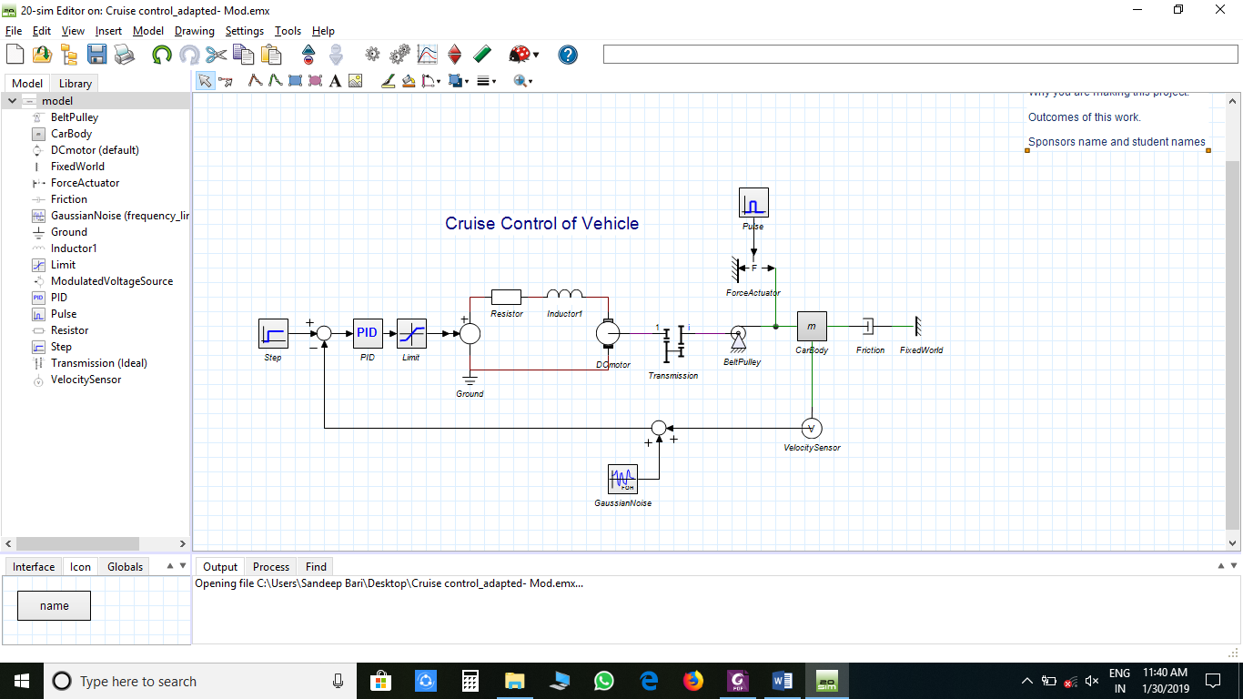

**Figure 4.2**

Figure 4.2, shows the modelling of the entire Automotive Cruise Control System. To adjust the car speed within the limits of specification, a controller has to be added. The problem of cruise control system is to maintain the output speed of the system as set by input signal base on the from the driver. Cruise controller design is applied assuming a single-loop system configuration with a linear model and nonlinear model, as shown in Figure 4.3

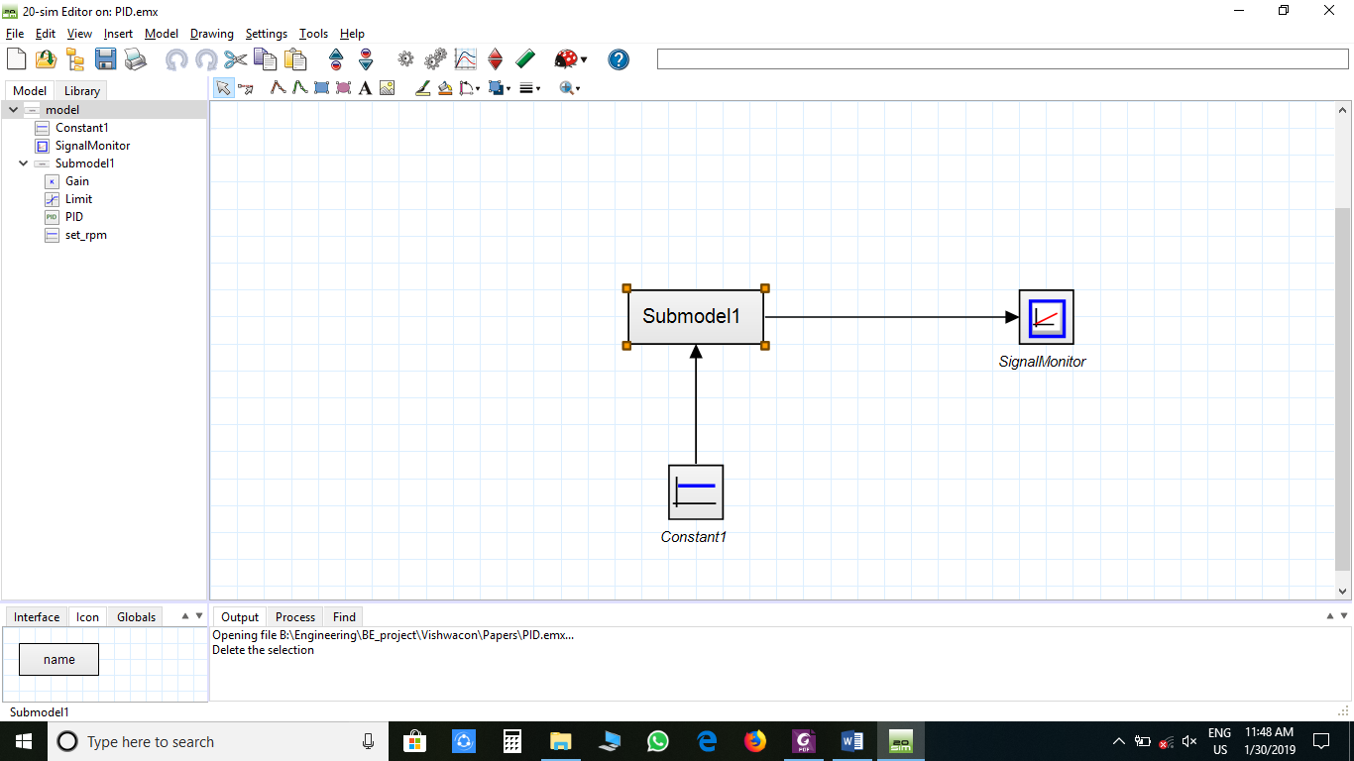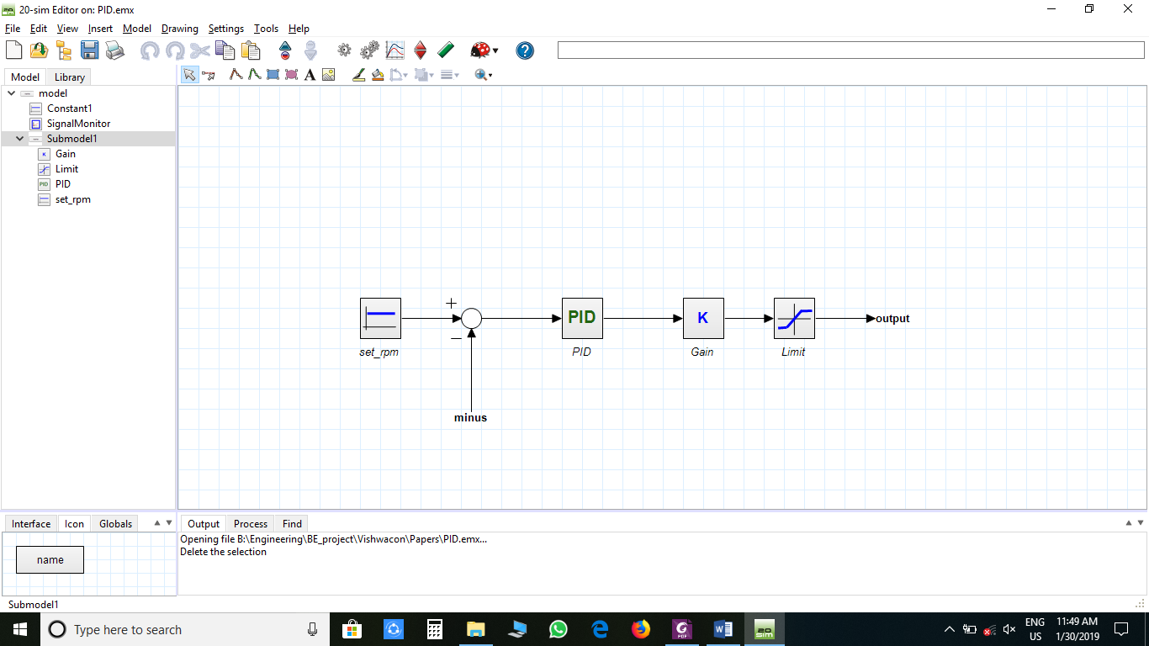

**Figure 4.3**

[6] Figure 3.3, shows the PID controller of ACC. Nonlinear model using PID controller is design of the controller has been based on use of the  
linearized model. Although a simple and quick check of the design, a more accurate simulation  
should be done by applying the controller to the original nonlinear model as shown in Fig. 3.3. The PID controller that take in consideration figure 4.3 describe as shown in figure 4.4

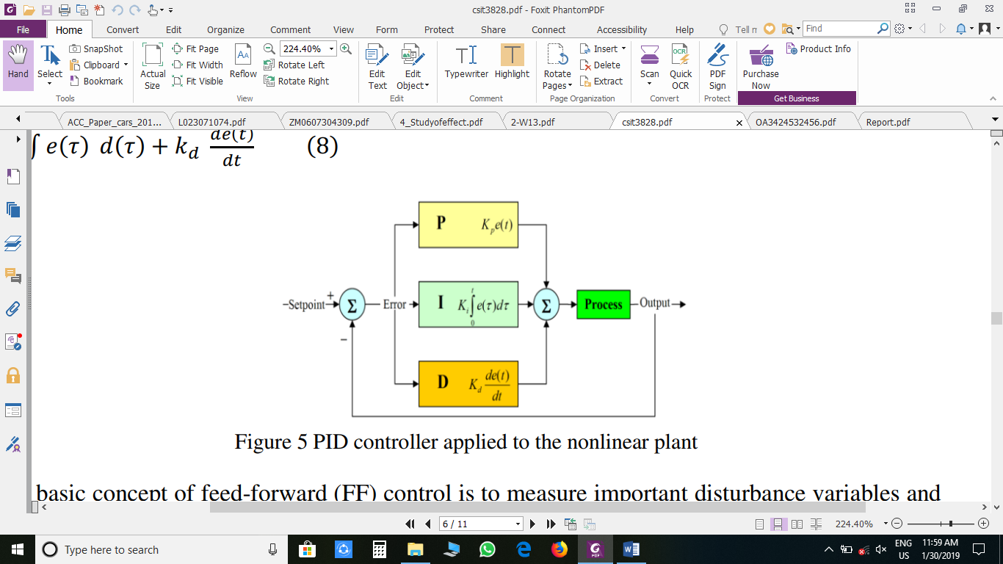

**Figure 4.4**

The closed-loop transfer function of the given system with a PID controller is

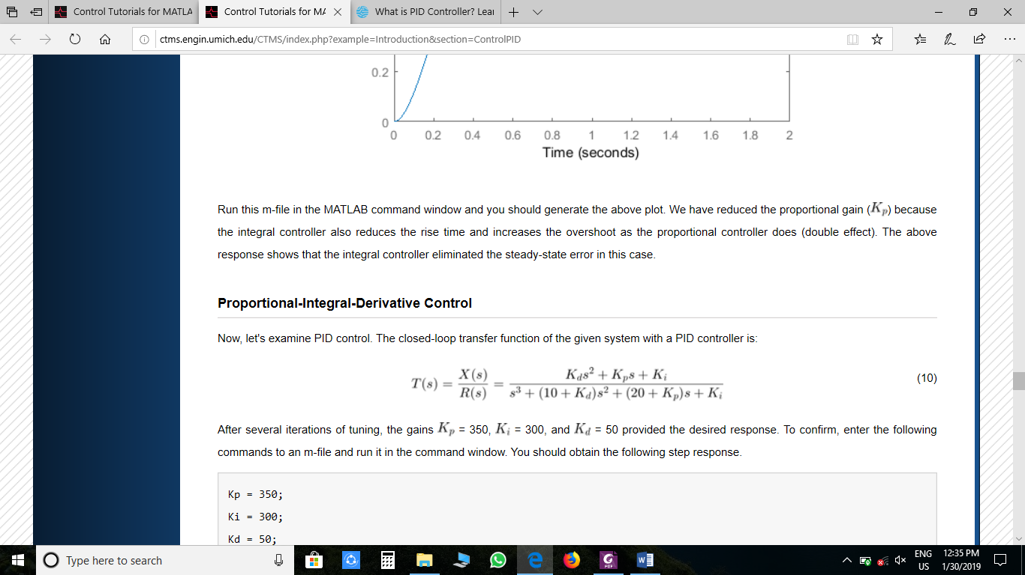

For desired output, this controller must be properly tuned. The process of getting ideal response from the PID controller by PID setting is called tuning of controller. PID setting means set the optimal value of gain of proportional (Kp), derivative (Kd) and integral (Ki) response. PID controller is tuned for disturbance rejection means staying at a given setpoint and command tracking, means if setpoint is change, output of controller will follow new setpoint. If controller is properly tuned, output of controller will follow variable setpoint, with less oscillation and less damping.

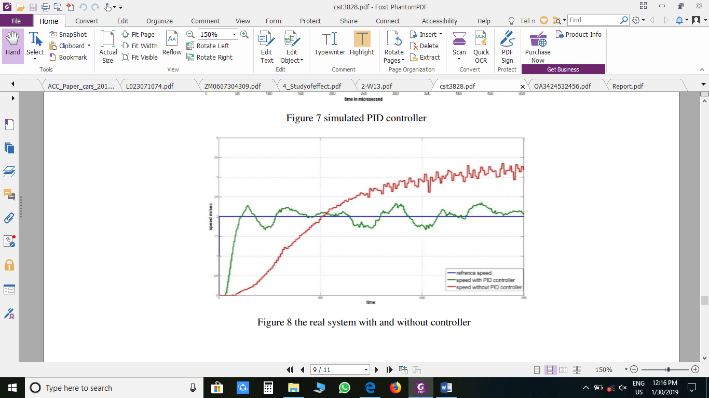

**Figure 4.5**

Figure 4.5, shows the real system with and without controller. There are several methods for tuning PID controller and getting desired response. Methods for tuning controller are Trial and error method, Process reaction curve technique, Ziegler-Nichols method And Using software. For different gain value we observe different curves as shown in figure 4.6.

[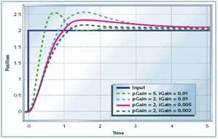](https://www.elprocus.com/wp-content/uploads/2013/12/PI-controller-response.jpg)

**Figure 4.6**

The general effects of each controller parameter (Kp, Ki, Kd) on a closed-loop system are summarized in the table below. Note, these guidelines hold in many cases, but not all. If you truly want to know the effect of tuning the individual gains, you will have to do more analysis, or will have to perform testing on the actual system.

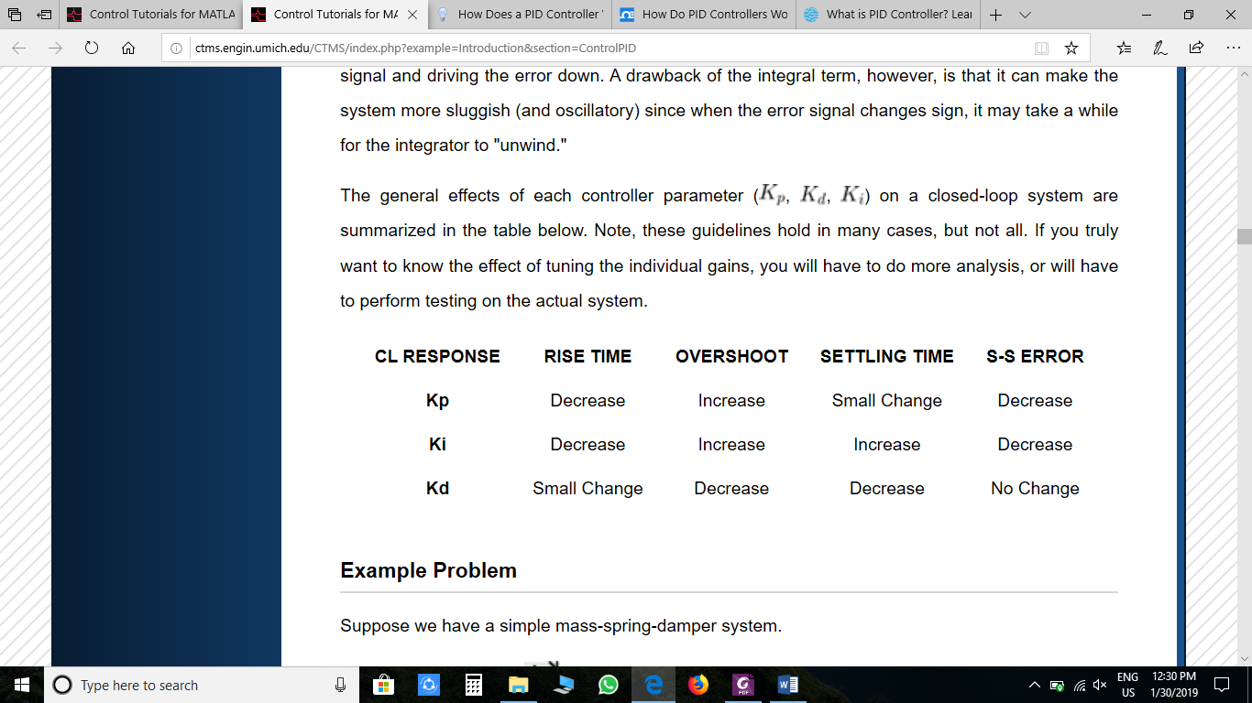

1. **20Sim Software**

20-sim supports four methods for modelling dynamic systems: iconic diagrams, block  
diagrams, bond graphs and equations and allows all of these methods to be used in one  
model. The package has advanced support for bond graph modelling, making it well known  
in bond graph communities. For modelling physical systems, the package provides libraries  
for electrical systems, mechanical systems, hydraulics systems and thermal systems. For  
block diagrams, libraries comparable to those of Simulink, are provided. A feature of the  
software is the option to create models with differential equations and package them as block diagram elements or physical components. 20-sim models can be simulated using state of the art numerical integration methods. After checking and processing, models are directly converted into machine code, resulting in high speed simulations. Unlike Simulink, simulation results are shown in 20-sim in a separate window called the Simulator. The simulator is versatile: plots can be displayed horizontally and vertically as time and frequency-based plots and 3D animations.  
20-sim is self-containing, i.e. no additional software is required and all toolboxes are  
included. Toolboxes are available for model building, time domain analysis, frequency domain analysis and controller design. To enable scripting, it is necessary to  
install either MATLAB, GNU Octave, or Python. The last is included as an optional feature in the 20-sim installer

1. **ADVANTAGES**

* Its usefulness for long drives (reducing driver fatigue, improving comfort by allowing positioning changes more safely) across highways and sparsely populated roads.
* Some drivers use it to avoid subconsciously violating speed limits. A driver who otherwise tends to subconsciously increase speed over the course of a highway journey may avoid speeding.
* Increased fuel efficiency.
* Encourages drivers to pay less attention to driving, increasing the risk of accident
* Since, the engine is running at a constant rpm, the vehicle returns good fuel economy.

1. **CONCUSION**

The project demonstrated the longitudinal vehicle model via simulation. This model is validated by a physical design along with the corresponding sensors and actuators. The mathematical model for cruise control system has been derived successfully and simulated cruise control system. This result from the simulated model is fed to the real system using 20Sim Software to the Arduino microcontroller with all the sensors interfaced and the best results that meets our system specification were achieved and overcome the effect of disturbance. This paper proposed ACC of a vehicle using PID controller. The proposed method provides speed tracking as well as providing the smooth variation of the vehicle acceleration. This research work presents a PID based control approach for automotive longitudinal control. The structure is designed with both verifying some safety and comfort constraints and assuring a good tracking of the desired control. The results further show that the system is doing well on all road grades i.e. Rough, Smooth, Hilly, Sloppy and Windy. This project is very feasible as very less expensive parts are used. Hence, the complete implementation of the concept is done also the various issues involved during implementation and the corresponding solution were discussed.

1. **FUTURE SCOPE**

The reliable intelligent driver assistance systems and safety warning systems is still a long way to go. However, as computing power, sensing capacity and wireless connectivity for vehicles are rapidly increasing, the concept of assisted driving and proactive safety warning is speeding towards reality. As technology improves, a vehicle will become just a computer with tires. There will be traffic congestion but no injuries or fatalities.  
Advanced driver assistant systems and new sensing technologies can be highly beneficial along with large body of work on automated vehicles such as Adaptive Cruise Control, Co-operative Cruise Control, The Cooperative Adaptive Cruise Control (CACC) is an extension to the adaptive cruise control concept. The distance & speed calculation can be modified and validated by using techniques and algorithm like ant colony, GA, neural network. Enhanced safety features and indication mechanism can be incorporated in the system design at the event of failure of cruise control mode of operation. These features can be activated depending upon the distance between the vehicles. The project can be further enhanced by using effective methods to detect the front vehicle in all road conditions & weather conditions using image processing techniques or Radar or some wireless techniques.

1. **MOTIVATION**

The objective of this is project is to eradicate many disadvantages of Cruise Control such as Manufacturing Cost, Simplicity and bring many such vehicles on the road. As electric Vehicles are going to hit the INDIAN market till the year 2020 such concepts will be  
very beneficial. The main objective of this project is to integrate the Cruise Control with  
the Electric vehicles and make it cheaper and bring it on roads as soon as possible. Vehicles Initiative in USA and the Ertica program of Europe are working on technologies that may ultimately lead to vehicles that are wrapped in a cocoon of sensors with a 360-degree view of their surroundings. Compared to these countries in India even Electric vehicles has not been so common and as Electric Vehicles are going to hit the INDIAN market till the year 2020 such concepts will be boon. This motivated us for undertaking this project and the secondary reason is an interest in undertaking a challenging project in an interesting area of research. The opportunity to learn about a new area of mechatronics not covered in lectures and working and making this happen under

‘n.i logic pvt ltd.’ was very appealing.

1. **REFERENCES**

* [1] Special Issue on 3rd International Conference on Electronics & Computing Technologies-2016 Autonomous Adaptive Cruise Control by Abhishek Patil, Soumi Sundararaman, Deepika Acharya, Bhushan Jadhav, Prasannati Kulkarni
* [2] A Review and Analysis of Literature on

Autonomous Driving Juan Rosenzweig,

Michael Bartl

* [3] American Journal of Engineering Research (AJER) e-ISSN: 2320-0847 p-ISSN : 2320-0936 Volume-6, Issue-7, pp-304-309

Optimal Design of Pid-Controller For Adaptive Cruise Control Using Differencial Evolution I. A. Dalyop and J. D. Jiya

* [4] International Journal of Advanced Research in Electrical, Electronics and Instrumentation Engineering (An ISO 3297: 2007 Certified Organization) Vol. 3, Issue 6, June 2014  
  Study of Effect of P, PI Controller on Car  
  Cruise Control System and Security  
  Jayashree Deka1, Rajdeep Haloi2
* [5] International Journal of Information and Education Technology, Vol. 1, No. 1, April 2011 ISSN: 2010-3689 Cruise Control Operation from Zero to Preset Speed-Simulation and Implementation F. A. Arvind Raj R., S. B. Sandhiya Kumar, Member IACSIT, IEEE and T. C. Karthik S
* [6] MODELING AND DESIGN OF CRUISE  
  CONTROL SYSTEM WITH FEEDFORWARD FOR ALL TERRIAN VEHICLES Khaled Sailan and Klaus.Dieter Kuhnert Siegen university .electrical engineering department Real time system institute Siegen, Germany
* [7] V.V Sivaji1, Dr. M.Sailaja / International Journal of Engineering Research and Applications (IJERA) ISSN: 2248-9622   
  Vol. 3, Issue 4 Adaptive Cruise Control Systems for Vehicle Modeling Using  
  Stop and Go Manoeuvres  
  V. V Sivaji1, Dr. M. Sailaja2
* [8] Adaptive Cruise Control: Experimental Validation of  
  Advanced Controllers on Scale-Model Cars  
  Aakar Mehra1, Wen-Loong Ma1, Forrest Berg1, Paulo Tabuada2, Jessy W. Grizzle3 and Aaron D. Ames1
* [9] The International Journal Of Engineering And Science (IJES) ISSN: 2319 – 1813 ISBN: 2319 – 1805 Adaptive Cruise Control  
  1,Minal Zunjarrao, 2, Sayali Shirude
* [10] Paper “Adaptive Cruise Control Towards a Safer Driving Experience” by Rohan Kumar and Rajan Pathak which was published in ‘International Journal of Scientific and Engineering Research’ Volume 3, ISSN 2229-5518.
* [11] Special Issue on 3rd International Conference on Electronics & Computing Technologies-2016 Conference Held at K.C. College of Engineering & Management Studies & Research, Maharashtra, India Autonomous Adaptive Cruise Control by Abhishek Patil, Soumi Sundararaman, Deepika Acharya, Bhushan Jadhav, Prasannati Kulkarni
* [12] A Review and Analysis of Literature on Autonomous Driving Juan Rosenzweig, Michael Bartl.
* ***<http://ctms.engin.umich.edu/CTMS/index.php?example=MotorSpeed&section=ControlPID>***
* [***http://ctms.engin.umich.edu/CTMS/index.php?example=Introduction&section=ControlPID***](http://ctms.engin.umich.edu/CTMS/index.php?example=Introduction&section=ControlPID)
* [***https://circuitdigest.com/article/what-is-pid-controller-working-structure-applications***](https://circuitdigest.com/article/what-is-pid-controller-working-structure-applications)
* [***https://trid.trb.org/view.aspx?id=478230***](https://trid.trb.org/view.aspx?id=478230)
* [***https://www.youtube.com/watch?v=vFHQV12RBq0***](https://www.youtube.com/watch?v=vFHQV12RBq0)
* [***https://www.lifewire.com/adaptive-cruise-control-definition-534813***](https://www.lifewire.com/adaptive-cruise-control-definition-534813)
* [***https://www.extremetech.com/extreme/157172-what-is-adaptive-cruise-control-and***](https://www.extremetech.com/extreme/157172-what-is-adaptive-cruise-control-and) ***how-does-it-work***
* [***https://auto.howstuffworks.com/cruise-control4.html***](https://auto.howstuffworks.com/cruise-control4.html)
* [***https://mycardoeswhat.org/safety-features/adaptive-cruise-control/***](https://mycardoeswhat.org/safety-features/adaptive-cruise-control/)
* [***https://talkford.com/community/topic/212026-adaptive-cruise-control-problems/***](https://talkford.com/community/topic/212026-adaptive-cruise-control-problems/)
* [***https://www.volkswagen.co.uk/technology/adptive-cruise-control-acc***](https://www.volkswagen.co.uk/technology/adptive-cruise-control-acc)
* [https://in.mathworks.com/help/mpc/examples/design-an-adaptive-cruise-controlsystem using-model-predictive-control.html](https://in.mathworks.com/help/mpc/examples/design-an-adaptive-cruise-controlsystem%20using-model-predictive-control.html)
* Wikipedia
* Yahoo